Them khach hang moi vao hang doi mua ve

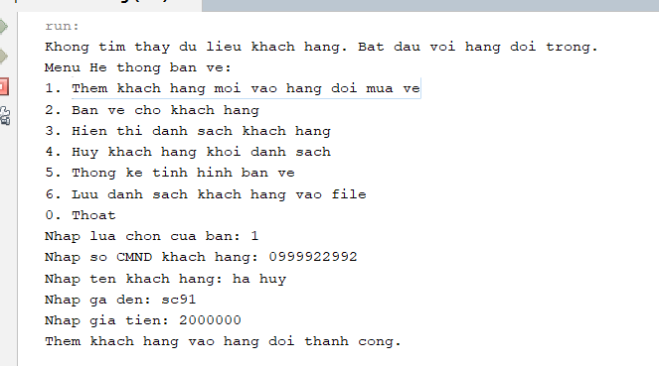

Ban ve cho khach hang

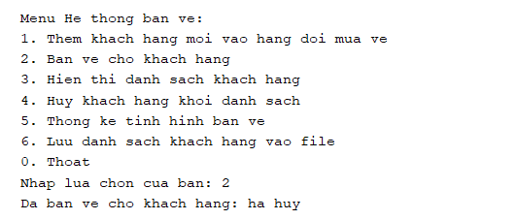

Hien thi danh sach khach hang

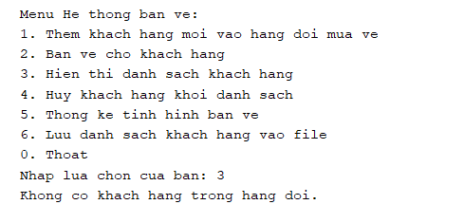

Thong ke tinh hinh ban ve

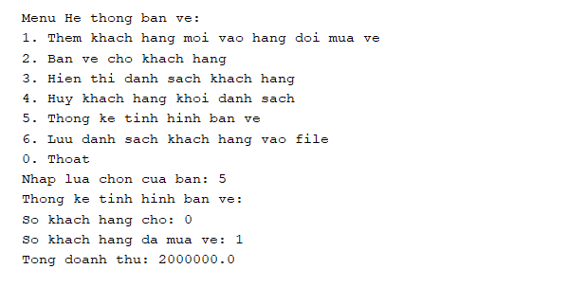

Luu danh sach khach hang vao file

